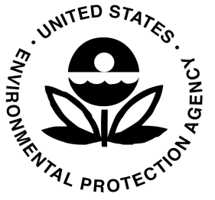 **EPA PUBLIC NOTICE**

**U.S. Environmental Protection Agency Reviews**

**Cleanup at the Facet Enterprises, Inc. Superfund Site**

The U.S. Environmental Protection Agency (EPA) is conducting its fifth five-year review of the implemented remedy at the **Facet Enterprises, Inc. Superfund Site,** located in the Village of Elmira Heights, Chemung County, New York. This review seeks to confirm that the implemented remedy continues to protect human health and the environment. The last five-year review was conducted in September 2017. A summary of the review and an evaluation of the protectiveness of the implemented remedies will be included in the five-year review report.

**What is a Five-Year Review?**

The purpose of a five-year review is to ensure that implemented remedies at Superfund sites function as intended and continue to be protective of human health and the environment. These regular reviews, which are required by federal law when contaminants remain at a site, include:

* inspection of the site and cleanup technologies;
* review of monitoring data, operating data and maintenance records, and
* determination if any new regulatory requirements have been established since EPA’s original cleanup decision was finalized.

**When will the Five-Year Review Report be available?**

It is anticipated that the five-year review report will be available at the website noted below by September 2022.

cleanup work and has transferred the properties to Heidelberg Township.

**For more information**

**You may also contact**

If you have any comments about the site, please contact:

**Aidan Conway**

***EPA Remedial Project Manager***

**Phone**: (212) 637-4227

**Email**: [conway.aidan@epa.gov](mailto:conway.aidan@epa.gov)

**OR**

**Michael Basile**

***EPA Community Involvement Coordinator***

**Phone**: (716) 551-4410

**Email**: [basile.michael@epa.gov](mailto:basile.michael@epa.gov)

There are several ways to review information on this site. The Administrative Record, which includes the EPA decision documents used for selecting the cleanup plan, is available for public review at the information repositories listed below. Project information is also available online at the website noted below.

Horseheads Town Hall

Town Clerks Office

150 Wygant Road

Horseheads, NY 14845

**OR**

EPA Region 2

Superfund Records Center

290 Broadway, 18th Floor

New York, New York 10007

(212) 637-4308 (call to make an appointment)

**For more information on this site, visit:**

**www.epa.gov/superfund/facet-enterprises**